Ansible is primarily for configuration management tool and widely used for deployment.

If you deal with multiple severs like 100 or 200 in that case deployment will be done using Ansible

If 5 or 10 you can use Jenkins ssh for deployment

If you want to deploy or install java or maven etc in 500 servers or any upgrades in 100s of servers ansible is one best option.

Rolling updates : if you want to upgrade any software in 100s of servers ,first user selects x percent of servers upgrade servers , pnce that’s done next take x percent of servers do the same process and repeat until all servers upgraded is called rolling updates. In ansible you no need to do this it will do all in once.

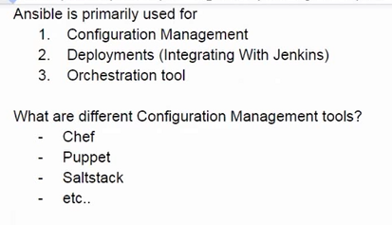

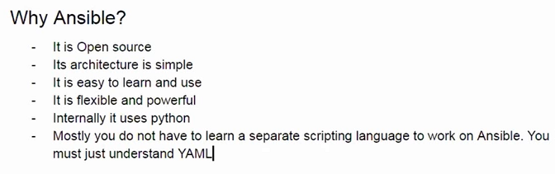

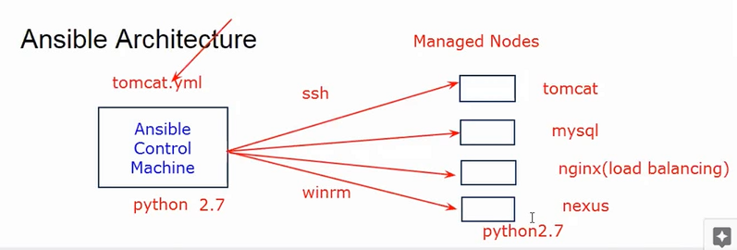

Ansible is agent less : no need to install agents on nodes on target nodes

Configuration file (like tomcat.yml in above fig) is called playbooks in ansible

Same files are called cook books in chef

If you remote machine is linux you can use SSH to connect remote machine

If it is windows winrm to connect remote machine

Minimum requirement is in both ansible control machine and target nodes you need to install python.

Ansible supports username and pwd and other option is user name and key for authenticating with manage nodes

**Setting up Practice environment:**

Lets take two virtual machines one for control machine and other machine for manage nodes.

Control machine is non-windows



Step 1 : Create new instance for Control Machine:



Default steps

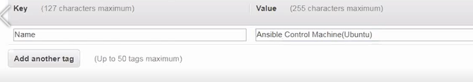

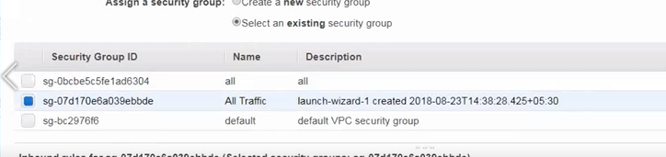

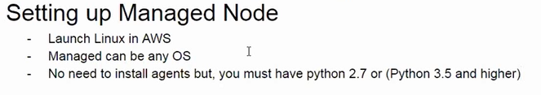

Lets connect to control machine instance

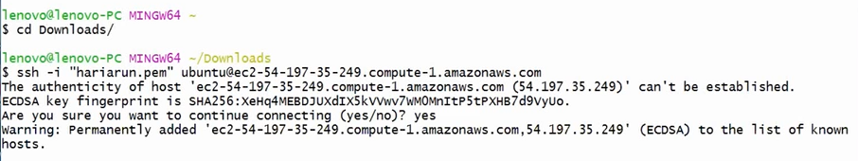

Run below 4 commands and if asks confirmation enter y

$ sudo apt-get update

$ sudo apt-get install software-properties-common

$ sudo apt-add-repository --yes --update ppa:ansible/ansible

$ sudo apt-get install ansible

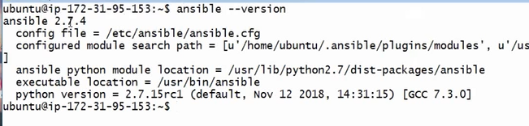

Setup Managing Nodes



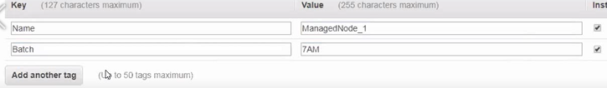

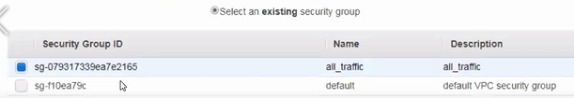

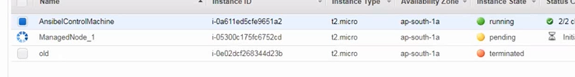



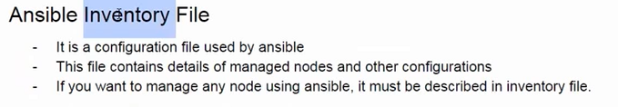

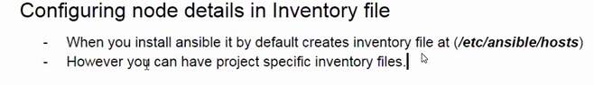

Now got to the control machine through gitbash

Run below command

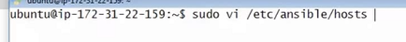

Hosts is file ,not a folder its shows lot of data in that file but everything is commented,but it helps as reference

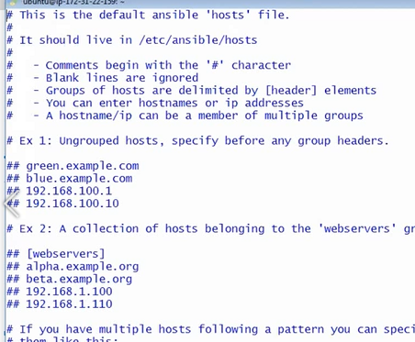

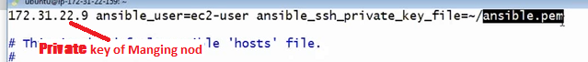

Enter above online text and enter :wq to come out it

Now you need to enter your key in above ansible.pem file

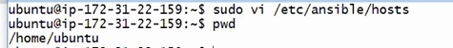



Go to the pem file in your local machine (downloads) and copy the key and paste in above editor



Enter :wq

Change the mode



Remember you are in control machine . now run the command below is private ip of machine nodes

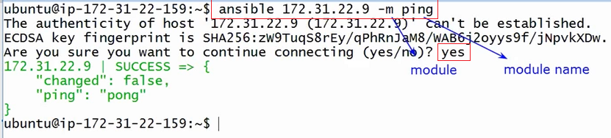

Now I want to run a command in managing node from control machine

All indicates in all manging nodes that will run the below command, currently we have only one managing node

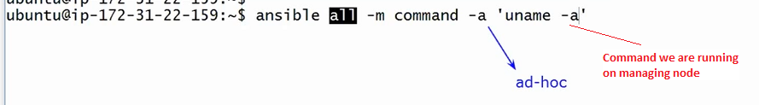

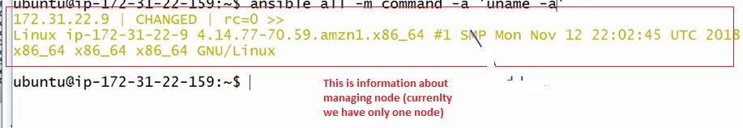

Now assume that I want to install git on all managed nodes (currently we have only one node)



--become is sudo command

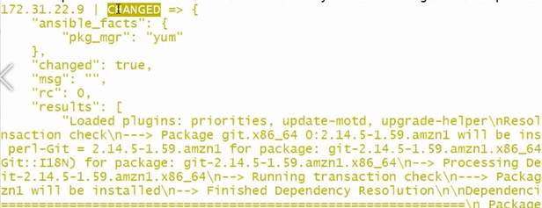

Changed means 🡪 earlier no git now it is get installed ..means git is installed successfully

If it is not installed it shows –unchanged

Ansible is Idempotent, if your node is already in desired state it will not redo it.

How to know packages available with name git

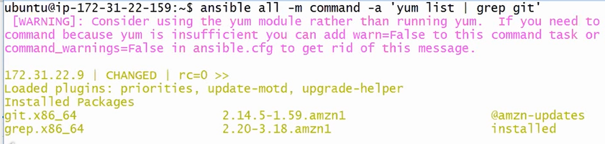

Ad-hoc ansible commands: On-fly you type and execute any ansible command is called ad-hoc command.

Ansible Playbooks : It’s a YAML file which contains all the details about how to configure your nodes.

Ad-hoc commands are powerful we typically use them for trouble shooting .

Writing Ansible playbook which should do the following.

Install Apache web server

Enable apache on reboot

Deploy index.html file on apache

Start apache server

YAML : Is a configuration file.

You can describe details in this file

Yaml file begins with 3 --- (its optional)

File extension is yml or yaml

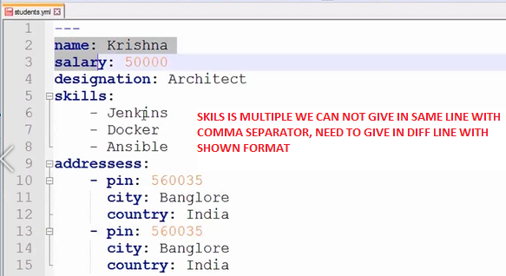

Inundation is very important in yaml file, above file is for employer you can give another employer details in same file.

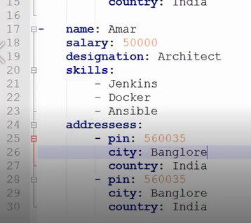

Now start to write YAML file

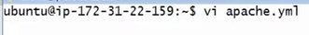

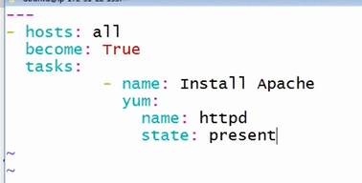

Enter : wq to come out

Now run the below command

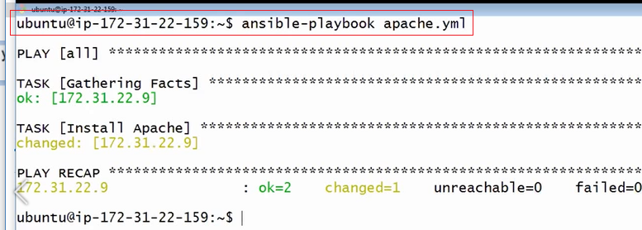

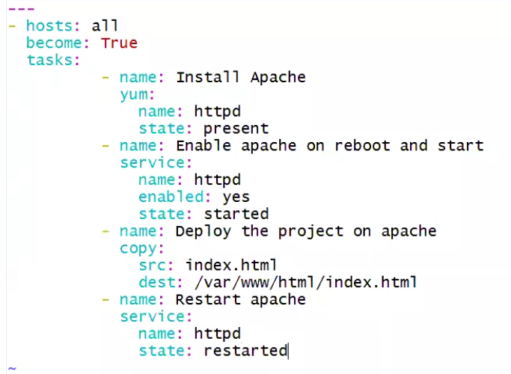

If you run the above file you can see the errors

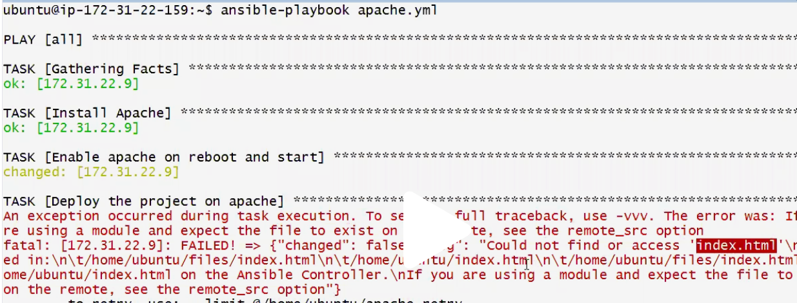





Enter :wq

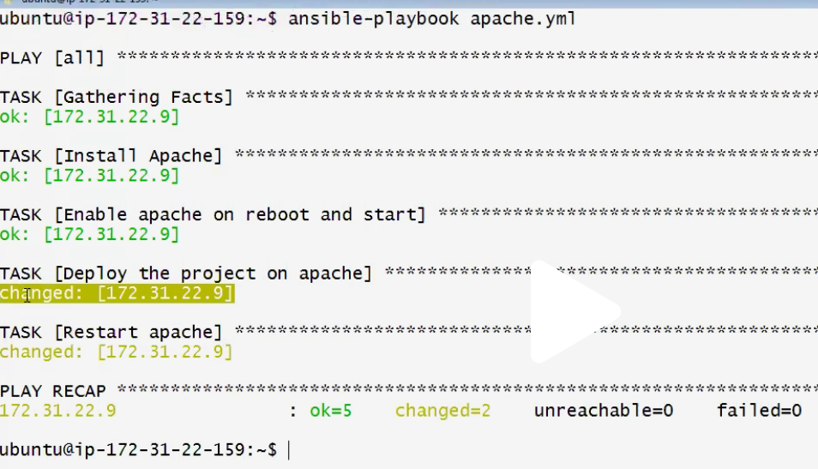

How to check deployed or not

Take the manage node public ip and paste in browser address bar



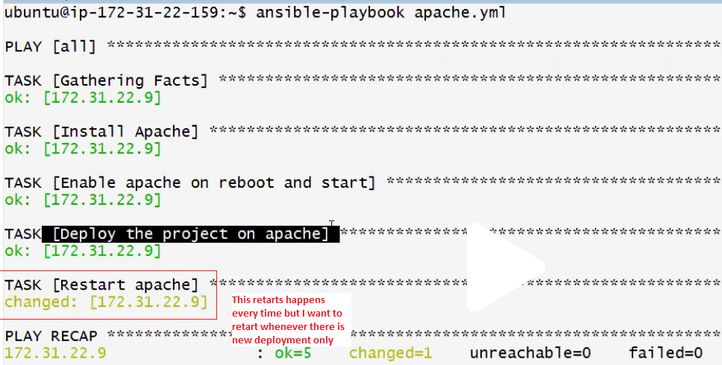

Ansible has handlers : Handlers are tasks which can be executed when someone notifies.

Go to the gitbash and open apache.yml file (vi apache.yml)

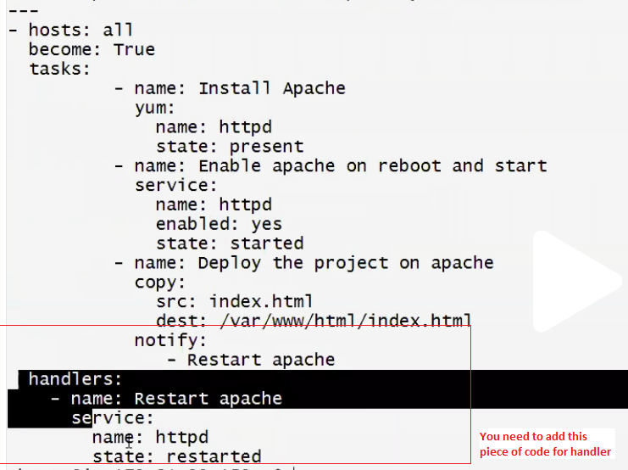

Now without changing the index.html run the below command, no restart will takes palce

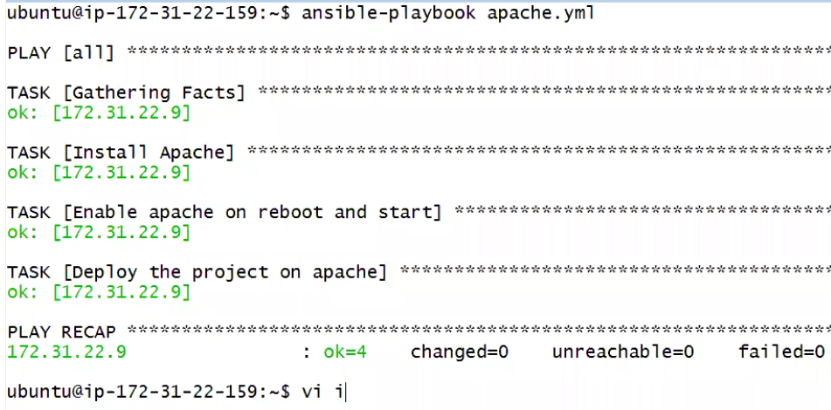

Now change the index.html run the below command, restart will takes place

Open vi index.html and change as follows,



Now run below command

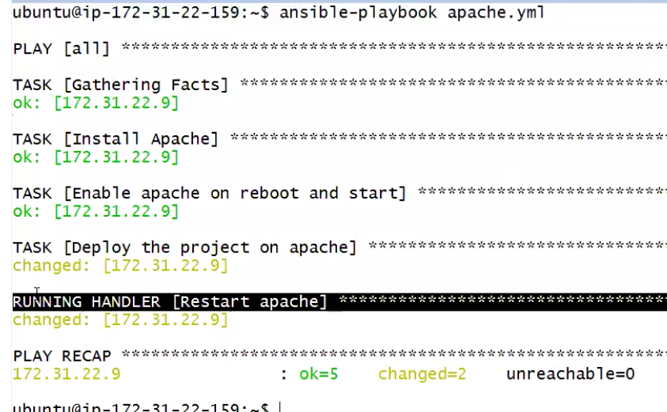

**Ansible Loops :** In ansible we can use loops for repeated tasks

Write a playbook for this loops,.. vi loops.yml

You can store play books in Jenkins or ansible towers, it is licensed version and it allows only playbooks not anything else.

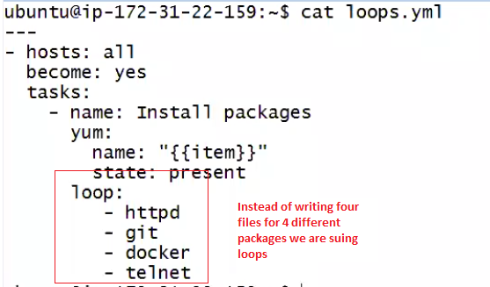

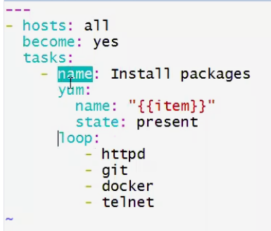

Now run the below command

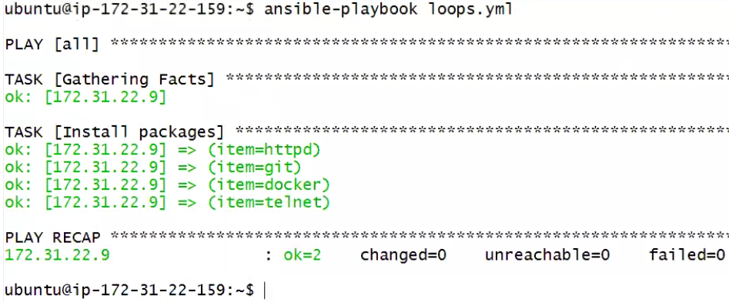

ANSIBLE CHANGES VERY FREQUENTLY IN above code earlier it was with-items instead of loop:

Another example : I want to create users

From gitbash open a file vi users-loops.yml

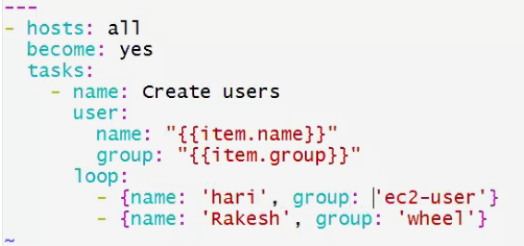

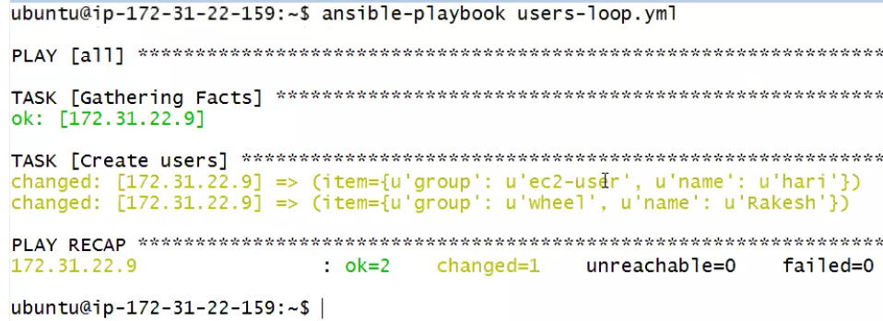

**Ansible Variables :**

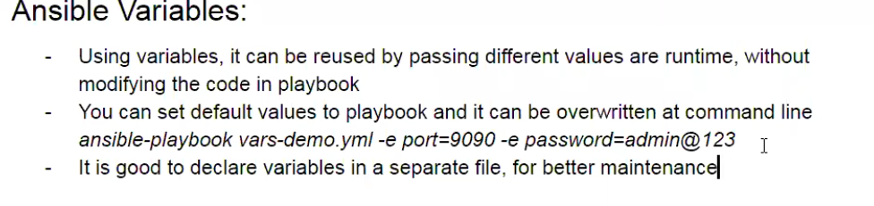

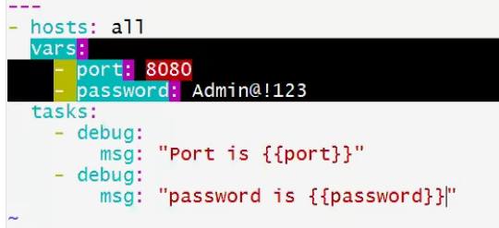

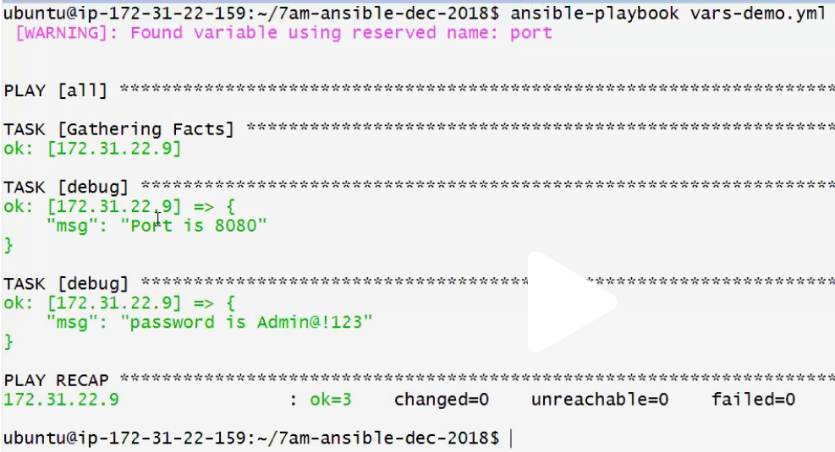

In above we gave the values of port and pwd are in vars-demo file, even we can pass through the command line



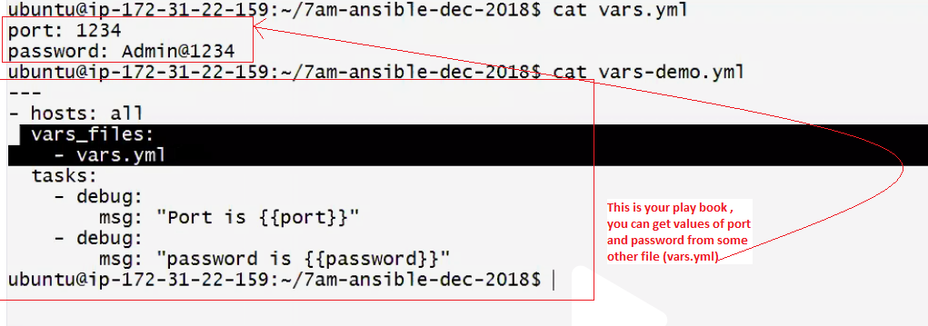

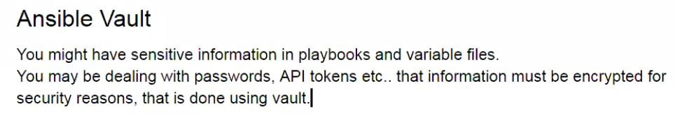

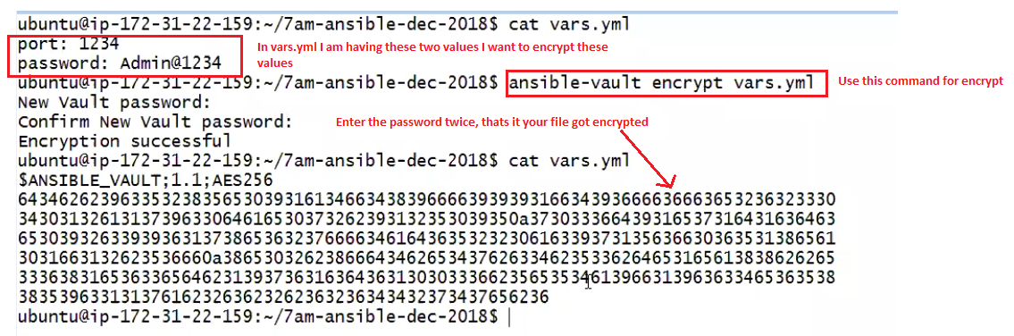

So the above password and other sensitive details file is encrypted , if I want to use this file in playbooks I need to give vault password

Now lets see how it perform if wont give vault password



There are diff ways to pass that vault password for decrypt that password , one of the way is you can pass it dynamically from command line.

There is command “- -ask-vault-pass” which prompts to pass the password.

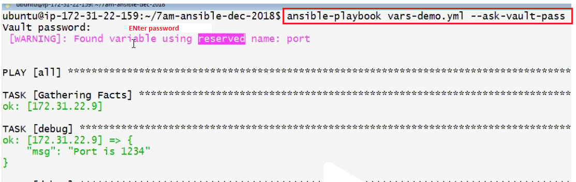

While running the playbooks using Jenkins , we cant give the passwords dynamically onfly , we need to keep some where in the file and we need to give the path of that file.

Create file using gitbash vi ~/vault.txt enter the password and exit from that file :wq



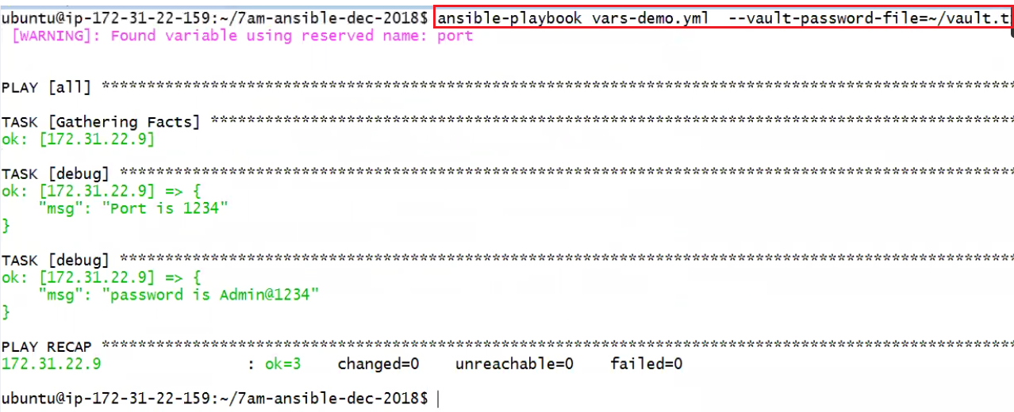

There is other way to pass the parameters : using environment variables

Some of the commands like edit ,view and decryot

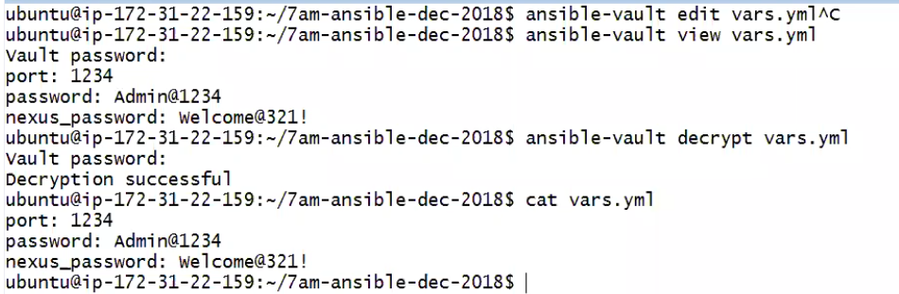

**Ansible conditions :**

Ansible support conditions , it executes tasks conditionally.

Open a file from git bash vi conditions.yml

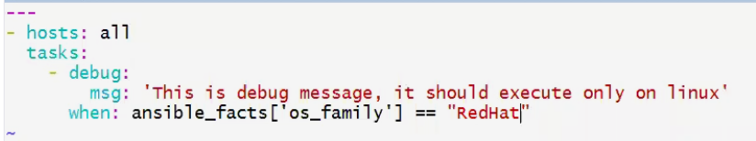

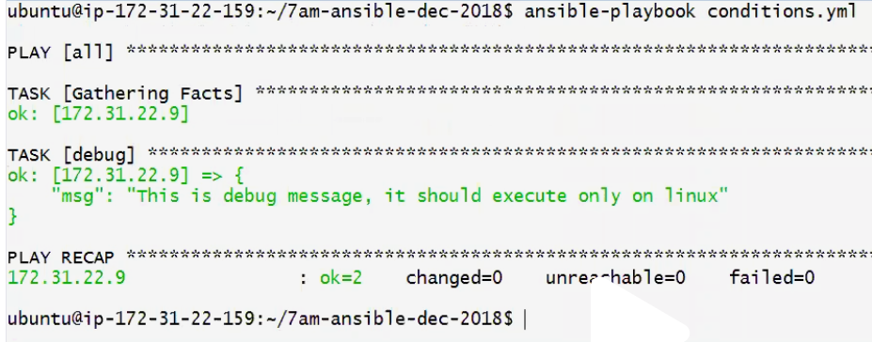

**Ansible Facts :**

Ansible gathers specific details about each and every node, that is how ansible knows os family of every node.

Setup is the command which pulls the managed nodes details



You can use and or in conditions.

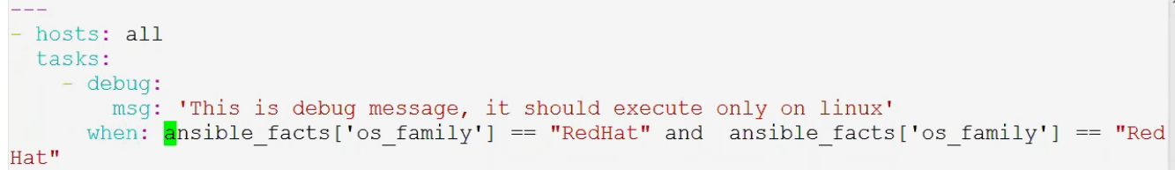

**Ansible Inventory :**

Default inventory we can see at



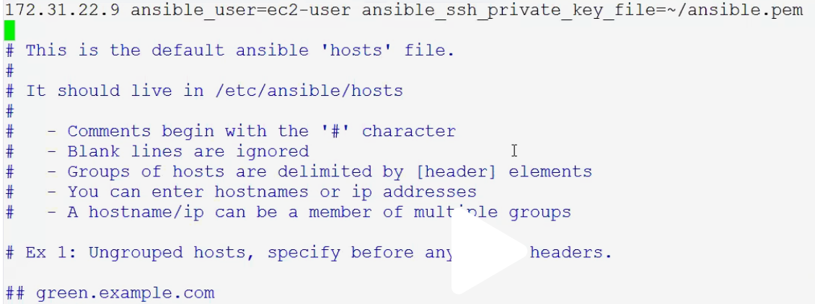

We can refer the node names instead of ip address, we can use alias names

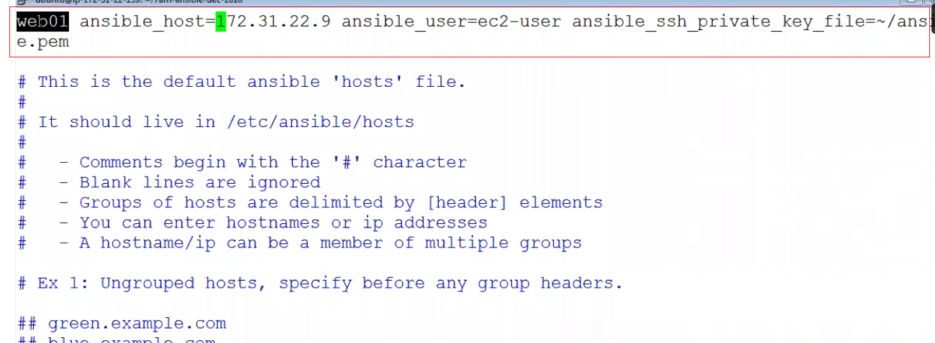

Now we can ping with alias name instead of ip address

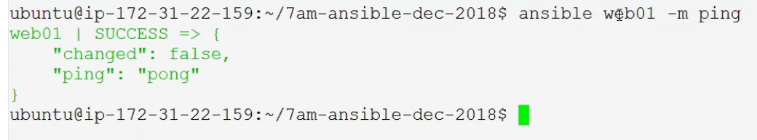

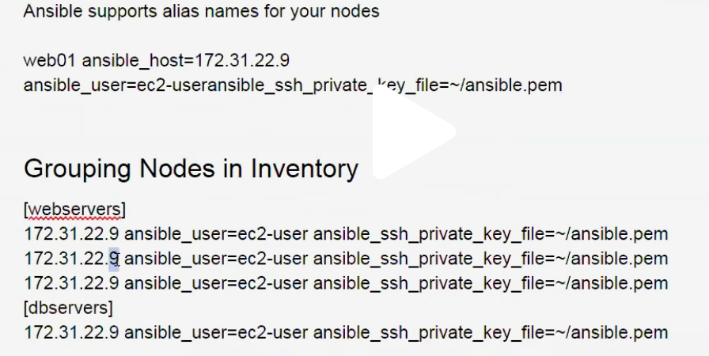

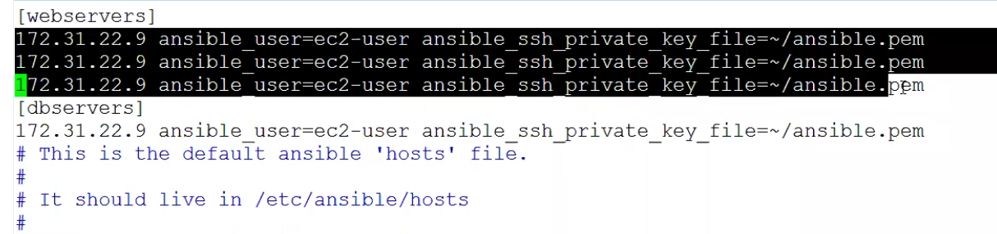

Using this group concept we can run playbooks on specific servers like web or db server

We can ping only webservers

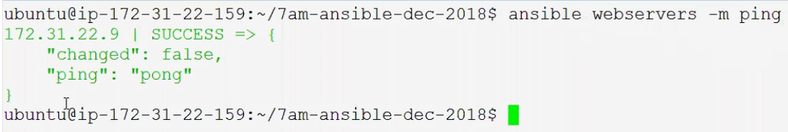

**Group Variables :**

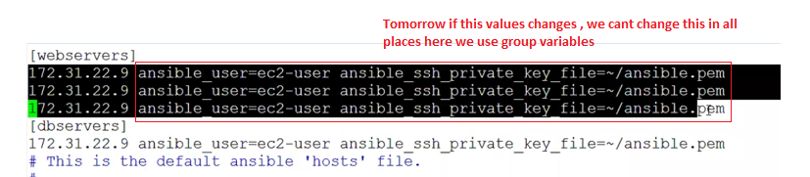

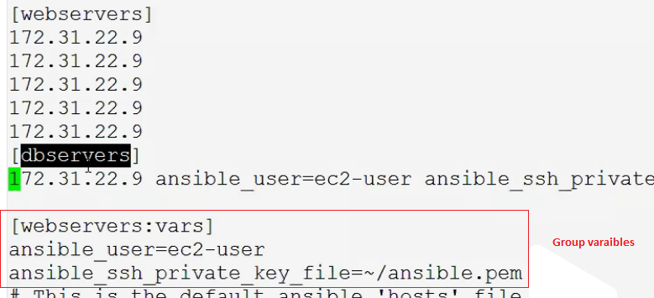

We can group the group of variables

Suppose there are 10 groups , if I want to run db and web servers , we can do this also

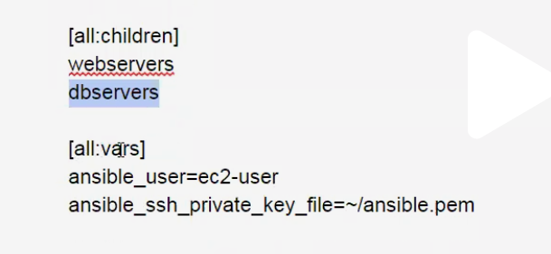

You ran a playbook on webservers group, play book execution fails only on one node.

They want to re run the play book only on that node.

Step 1: following run on all webservers

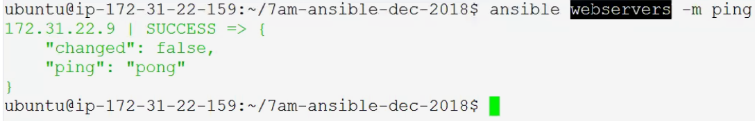

Suppose I want to run play book on first node



Using retry command we can check the failed node

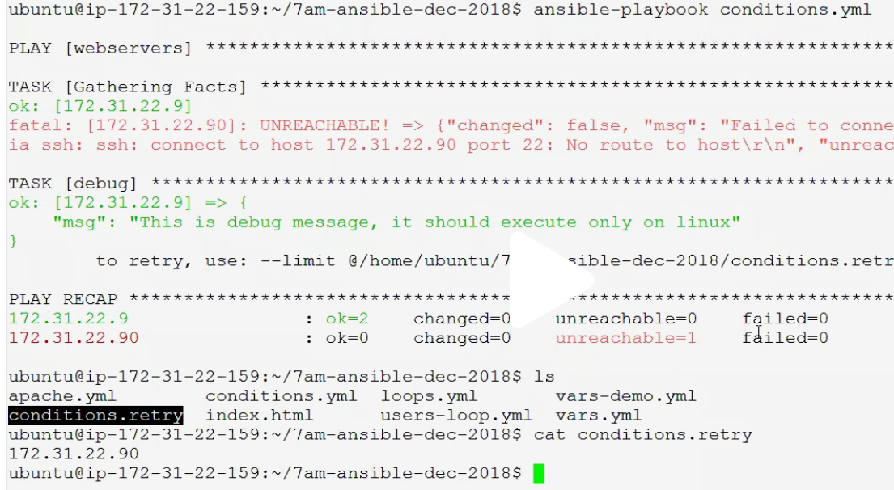

How to display all host environments (while practicing ,ram u may get one)

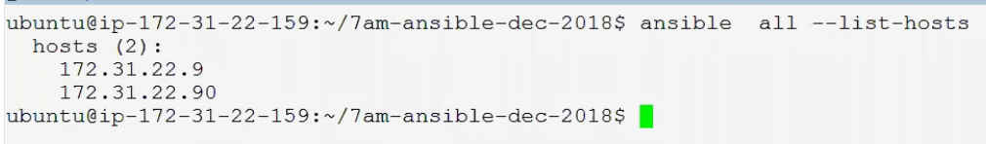

**Ansible Tags :**

While running the playbooks using tags we can run the selected tasks (create a file tags-demo.yml)

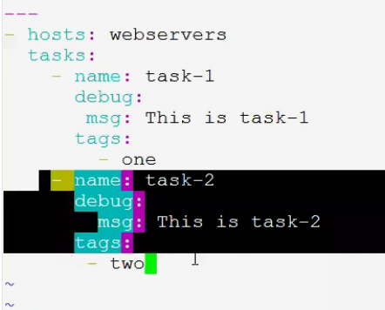

It will run all tags for below command

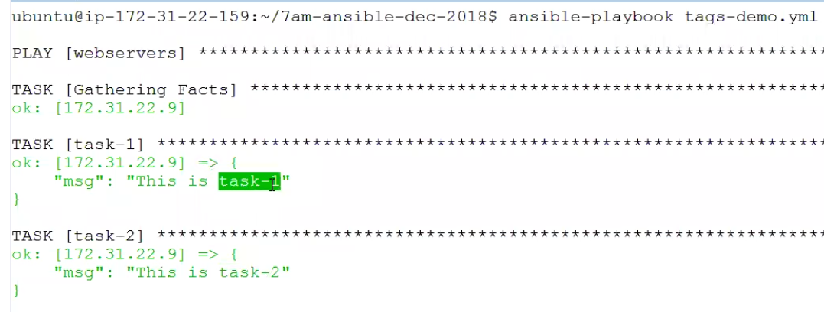

How to run specific task

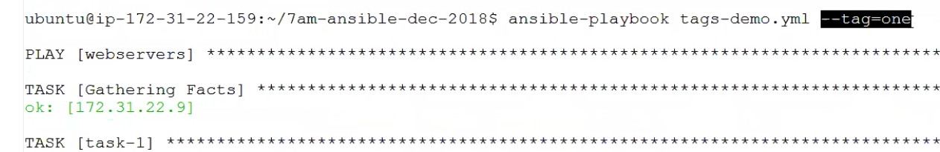

If u want to skip a tag and run all other tags we can use –skip-tag-one



We can check the syntax also SYNTAX-CHECK

Now I am intentially inserting issue by changing the inundation (debug is not in proper)

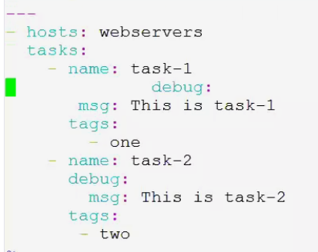

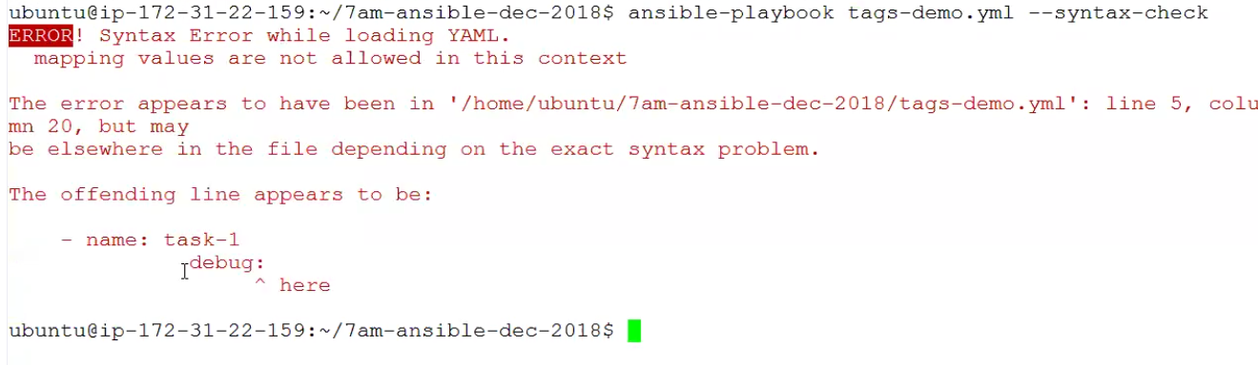

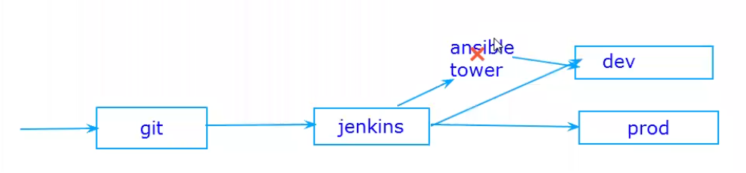

We keep the playbooks in ansible tower and that play books we can trigger from Jenkins

Currently we are not talking about ansible tower

**Writing Reusable Playbooks :**



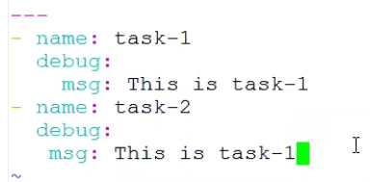

Above is task we need to reuse it somewhere else

Create a new file vi main.yml

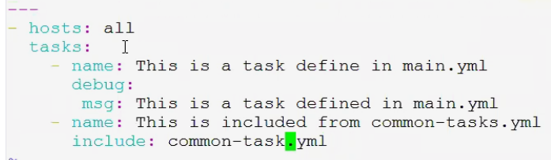

Now run the common file



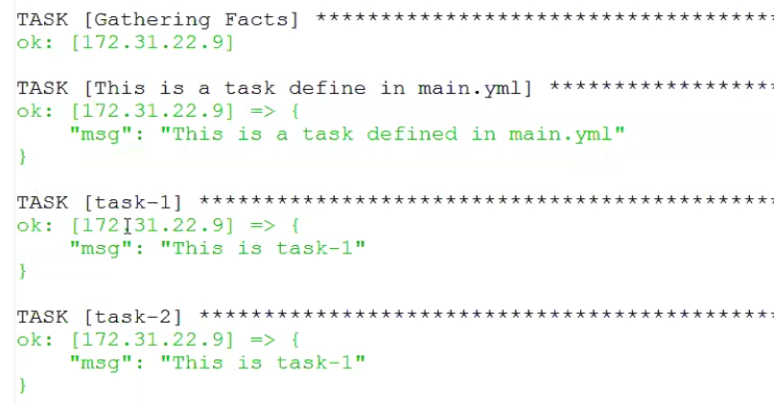

**Ansibles files and Templates :**

Ansible file : For example we are installing and configuring the tomcat using ansible

As part of this configuration we want to add two rows and two users in tomcat-users.xml, this file is called configuration file. We can have this file in ansible project on control machine. Using copy module we can copy this file from control machine and put it on all tomcat nodes.

In this scenario the file we are using is normal file.

Ansible Templates : We can use jinja2 its templating engine for managing dynamic files tool.

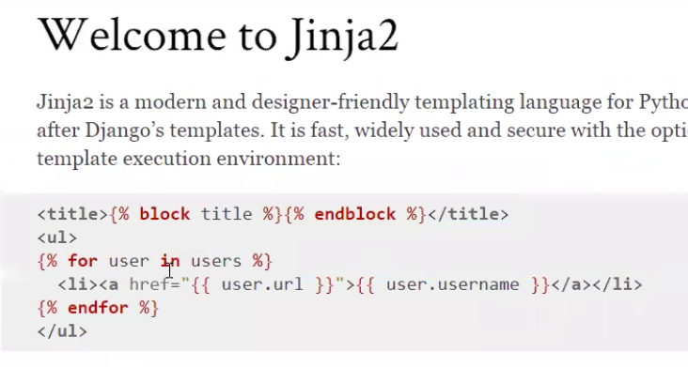



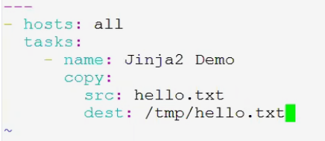



Just write a below any plan text in hello.txt

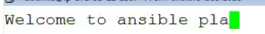

Now run the playbook

Av

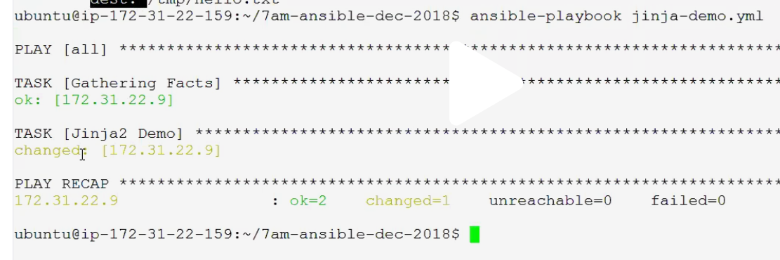

Above is Ansible file, now we need to demo on Ansible Template



Enter below code

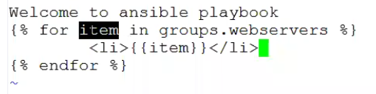

Open below file and update it accordingly with template details



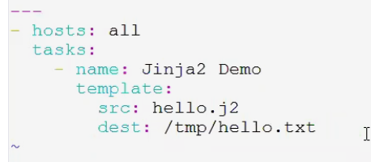

Now run the playbooks

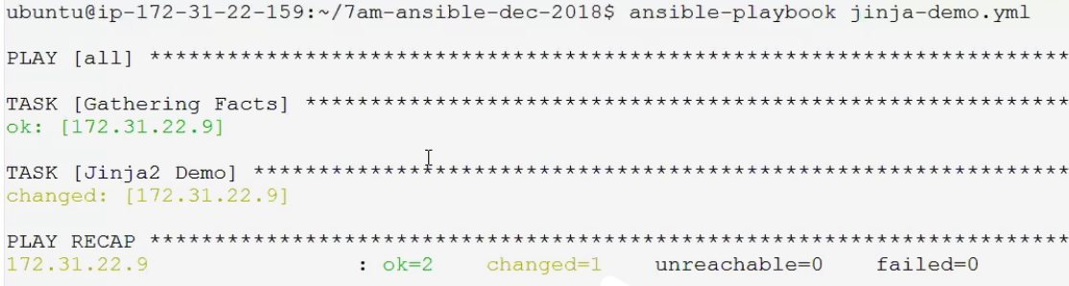

Ansible Roles :

Is a standard where we will maintain all in a proper folder structures which give more maintainability and reusability.

Below guy written a book on ansible , you can use his few concepts from his git hub



Create folder for roles and you have to create all your roles in that folder





Now start create your roles in that folder

In roles folder we create a subfolder for every package and that package contains files and tasks

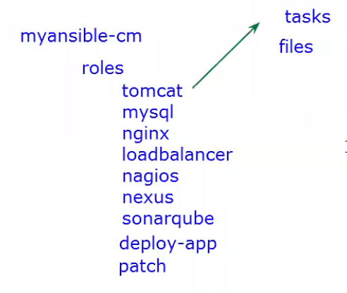

Command to create a role

Install and configure a load-balancer using a role

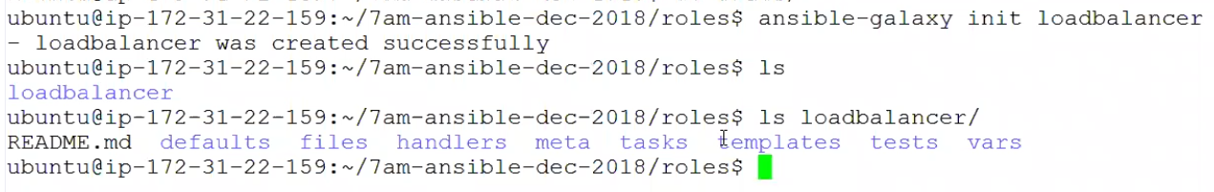

Lets write a role for loadbalancer

We need to have THREE instances for Loadbalncer and for 2 apache,..create two instances in AWS

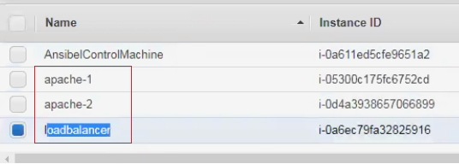

We should configure node details in inventory

Enter private ips of all three instances in below



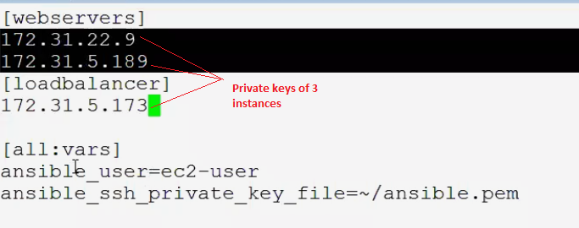

After updating as above come out from that file :wq

Disabling host key checking in ansible,we should do this in ansible config file





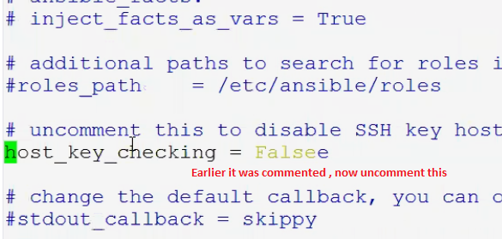

After updating the invenstory and config lets comeback to our project

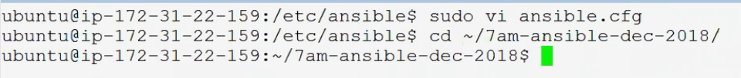

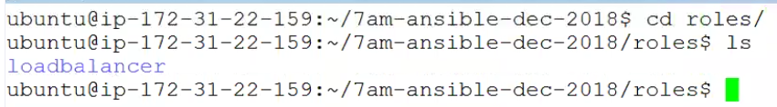

Lets create a role for apache

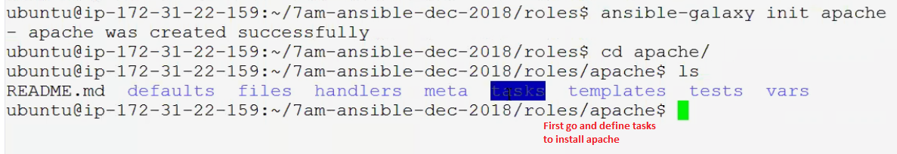

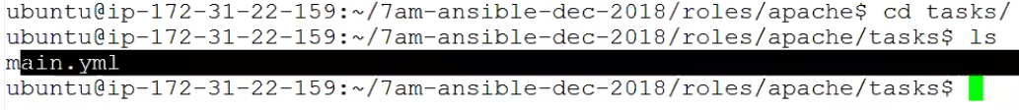

Go to vi main.yml

Add below code in to above file

|  |
| --- |
| - name: Install Apache |
|  |

|  |
| --- |
| yum: |
|  |

|  |
| --- |
| name: httpd |
|  |

|  |
| --- |
| state: present |
|  |

|  |
| --- |
| - name: Enable apache on reboot and start |
|  |

|  |
| --- |
| service: |
|  |

|  |
| --- |
| name: httpd |
|  |

|  |
| --- |
| enabled: yes |
|  |

|  |
| --- |
| state: started |
|  |

|  |
| --- |
| - name: Deploy the project on apache |
|  |

|  |
| --- |
| copy: |
|  |

|  |
| --- |
| src: index.html |
|  |

|  |
| --- |
| dest: /var/www/html/index.html |
|  |

|  |
| --- |
| notify: |
|  |

- Restart apache

It looks as follows inanduation is important

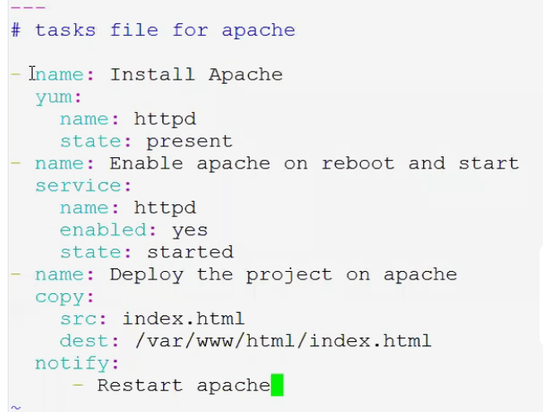

In above check index.html file where it is

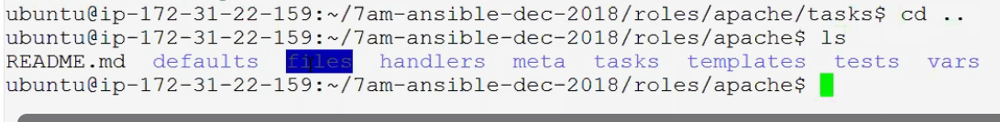

Using WGET they are getting associating the directly from githubjavahome



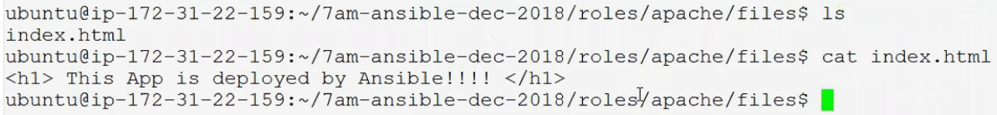

Now we need to reatrst , where we will do this ,..go to handlers

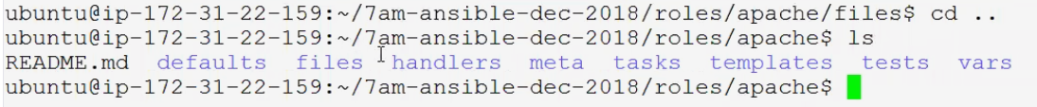

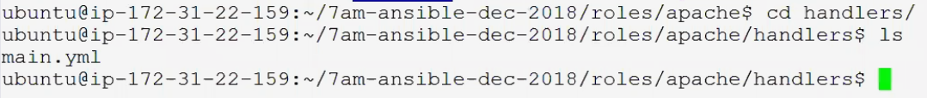



Open main.yml ..vi main.yml

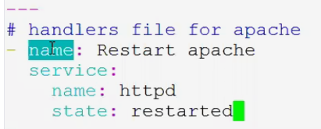

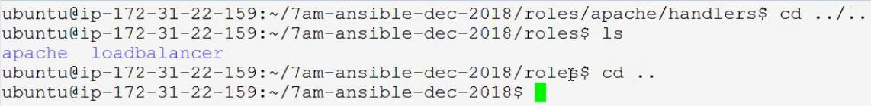



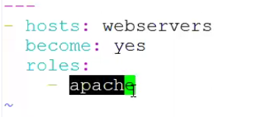



Go and check apache-2 – take the public ID enter that value in browser



Now go to the index.html modify the value (This App deployed by Ansible!!!!,..modify or add some text like ram)

Now follow below commands



Now go and check the public id of apache, you can see the updated value in browser



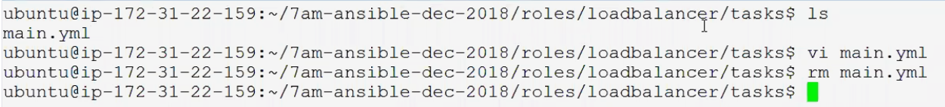

Directly get a file from javahome

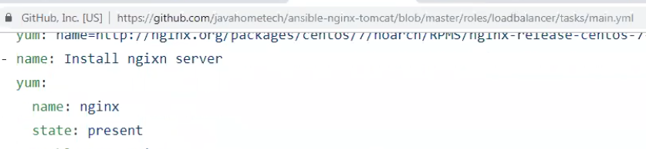

Run below command which directly pick the above file from git



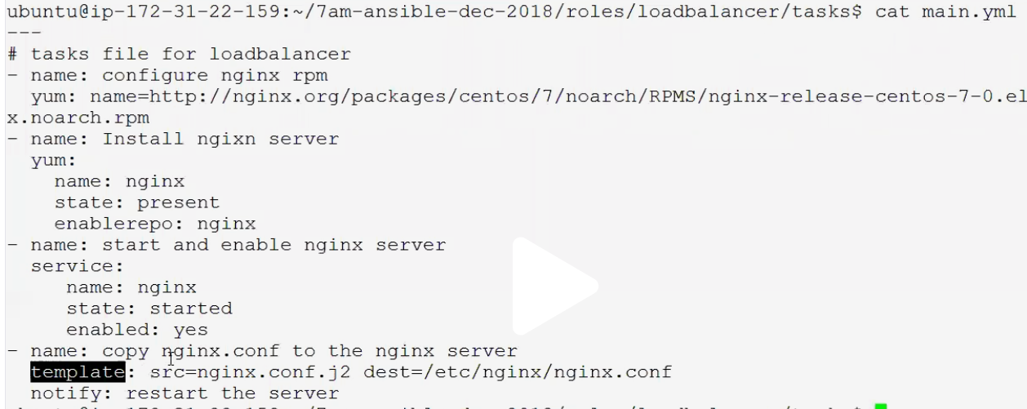

Now we need to take care of nginx from template module (go to the git hub/javahome)

<https://github.com/javahometech/7am-ansible-dec-2018/tree/master/roles/loadbalancer/templates>

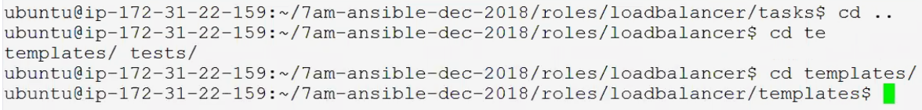

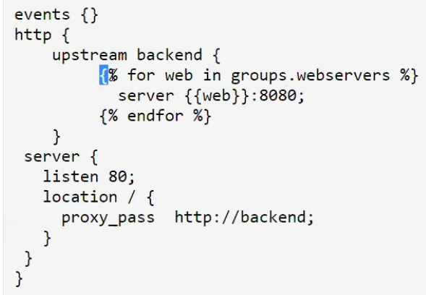

Above is config file used by nginx for load balancing

We need to modify the above file, first get it as follows





Our servers are runs on 8080, we no need to mention explicitly remove 8080 from above file

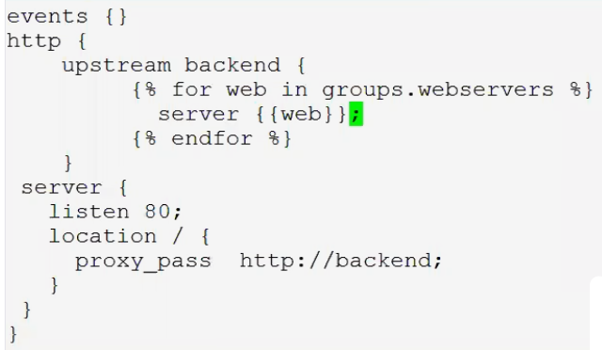

Go to the tasks

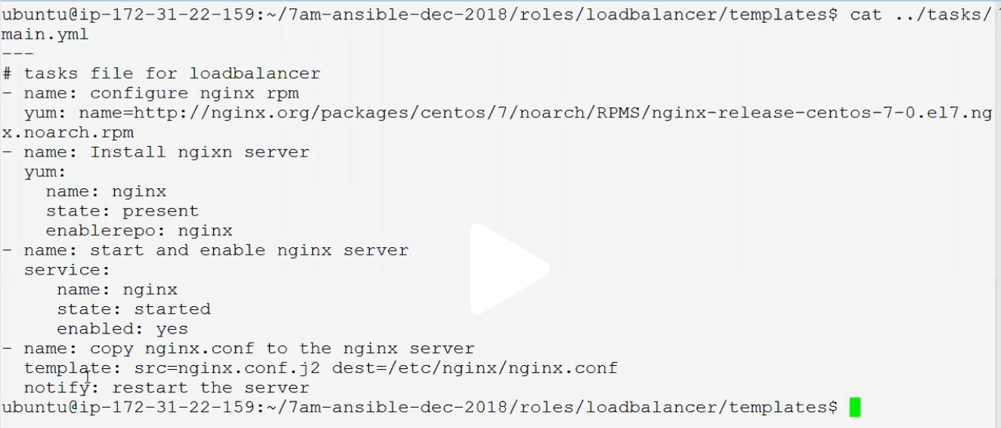

At last in above screen you can see notify : retstart the server , ..so we need to give some handlers details

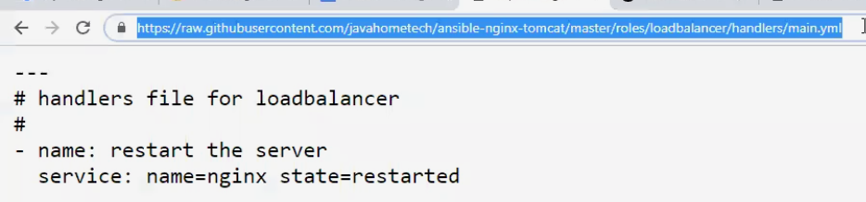

Again get it from git (get the url after clicking on raw)

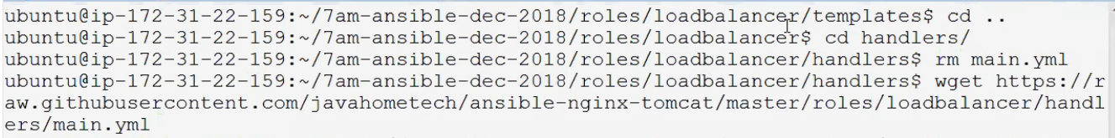

With this role is ready , so where do we need to use the load



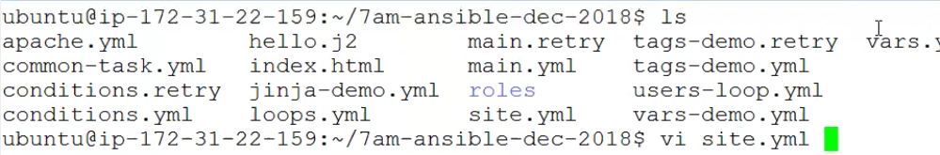

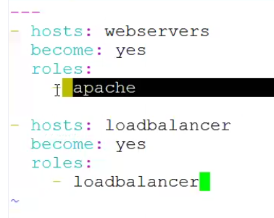

After updating as above now run the below play book



Go to aws and get the load balancer public ip address and enter that in browser



Interview question : What are the folders you see in roles :

Files, templates, handlers tasks default vars meta

Lets discuss about meta

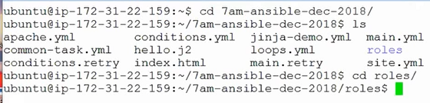

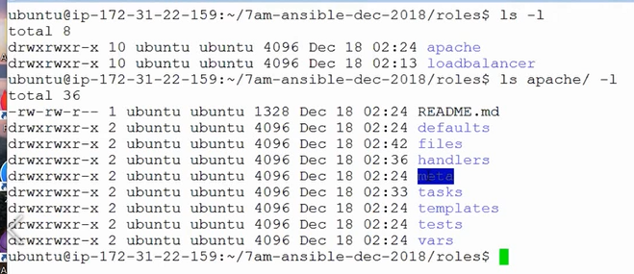

Meta folder contains details like : Authors company description and plat form it works on

Variables : you declare all your variables (like port numbers ,java version etc)

Defaults : This is for default variables,

Ansible Galaxy : It is a registry of ansible roles.

How do you do rolling updates in Ansible :

Using the Ansible serials ,we can update the rolling updates.

A serial can be number or percentage.

What is dynamic inventory in Ansible

Dynamic inventory used in cloud environment

How to communicate control machine and Managed nodes without password

On control machine you must create public private key

Take public key, configured this public key on node and repeat this proess on every node.Once its done no password required.